TIS Digital Backpack
April 5, 2024

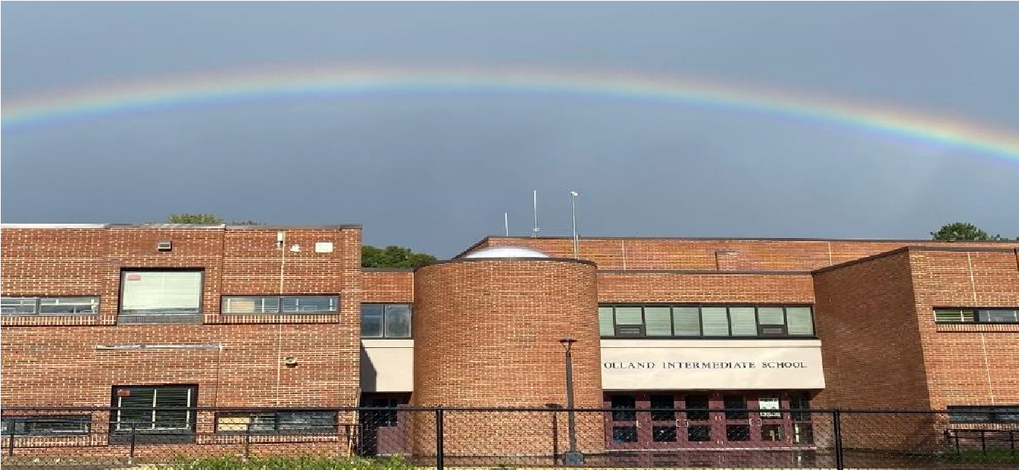
Photo courtesy of M. Lachut

FROM THE PRINCIPAL’S OFFICE:

Fifth Grade Promotion Ceremony

We would like to take this opportunity to invite you to the Tolland Intermediate School Fifth Grade Promotion Ceremony. The ceremony will be on the last day of school, June 14, at 9:30 a.m. in our gymnasium. The promotion ceremony will be an opportunity to celebrate the children’s completion of the elementary school chapter in their lives. Due to space constraints, we ask that no more than two people per family attend the ceremony.

Superhero Day at TIS - April 5

Friday, April 5 was our fourth annual Superhero Day at TIS. For this year’s Superhero Day all students and staff were encouraged to wear something reminiscent of their favorite superhero.

Thank you PTO
Thanks to the PTO for funding another shipment of books for our book vending machine. Thanks to Mrs. Comeau, Mrs. Lester and Mrs. Silberberg for choosing books among a lengthy list of best-selling children’s books.

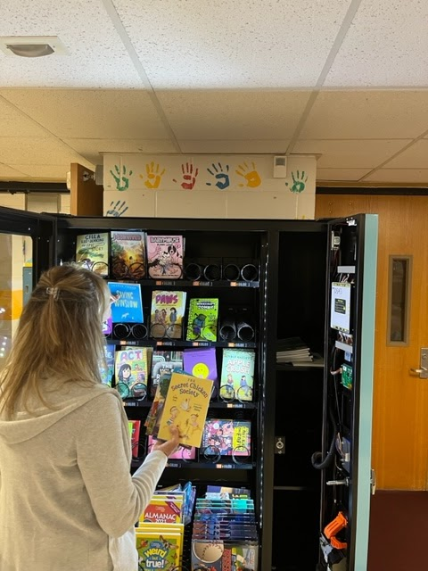
Mrs. Lester is shown filling our book vending machine with books,

T.I.S. CALENDAR

APRIL
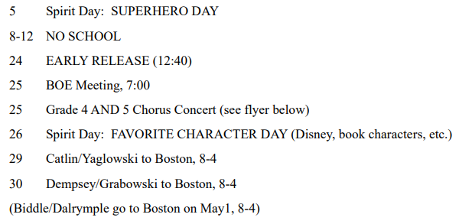

TOLLAND PUBLIC SCHOOLS
2024-2025 CALENDAR
Please note: You can access this calendar on the school’s website or by clicking the link below:
Approved-2024-2025 BOE Calendar.pdf - Google Drive

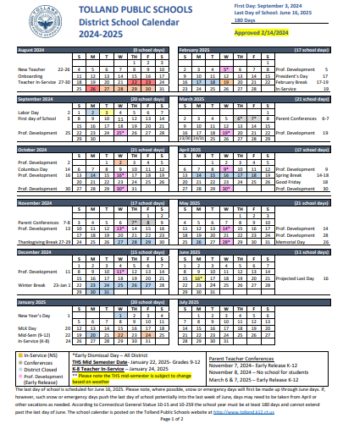
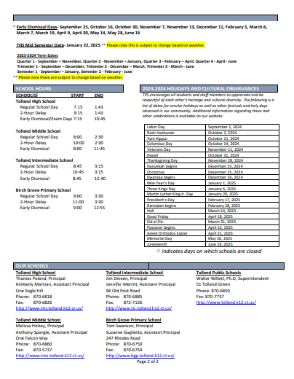

NEW ITEMS THIS WEEK:

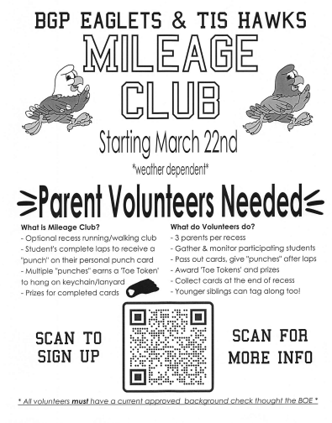

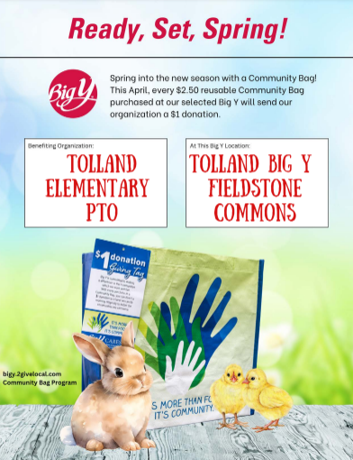

Tolland Family Resource Center
Preschool 2024-2025

Our preschool programs promote child-initiated exploration in a safe, secure, and nurturing environment. All classes provide a balance of play, social time, and structured learning activities.

Tolland FRC 3’s Preschool for three-year-olds
Schedule: Tuesday and Thursday - 9:00am – 12:00pm / located at Birch Grove in room B14
Children must be 3 on or before December 31, 2024.

Tolland FRC 4’s Preschool for four-year-olds
Schedule: Monday, Wednesday, and Friday – 9:00am-12:00pm/ located at Birch Grove in room B14
Children must be 4 on or before December 31, 2024.

Creative Preschool for 3- to 5-year-olds
Schedule: Tuesday, Wednesday, and Thursday - 9:00am – 12:00pm / located at Tolland High School room 85.
Children must be 3 on or before December 31, 2024.

Kindergarten Readiness for those children not eligible for kindergarten due to the new state regulation.
Schedule: Monday – Friday 9:00-3:00 /located at Birch Grove in room B12.
Children must be 4 on or before September 1, 2024.

How can you help your child succeed in preschool?
A positive preschool experience can help set your child up for future success in kindergarten and beyond. You can help to ensure your child will flourish in a preschool class by working on the following readiness skills:
- Listening and following simple directions.
- Expressing wants and needs verbally.
- Following a routine with multiple transitions.
- Sharing and taking turns with friends and family.
- Self-help skills such as getting dressed, using the restroom, and eating lunch/snack with minimal assistance.

We strongly encourage families to begin working on toilet learning prior to the start of the school year. Please let us know if you need support and guidance during this learning process.

FRC Preschool 2024-2025 Registration Form

Join the Family Resource Center’s School Age Care Programs
Where friendships are formed.
We provide time for homework, snacks, free play, crafts, and outside play.
We hold programs at both Birch Grove Primary School and Tolland Intermediate School.
We provide morning care from 7:00 am-until the start of school and after school care from the close of school until 6:00 pm.
We are open on scheduled early release days as well as all Teacher Inservice & Parent Teacher Conference Days.
Please follow the link to register.
FRC 2024-2025 SAC Registration Form

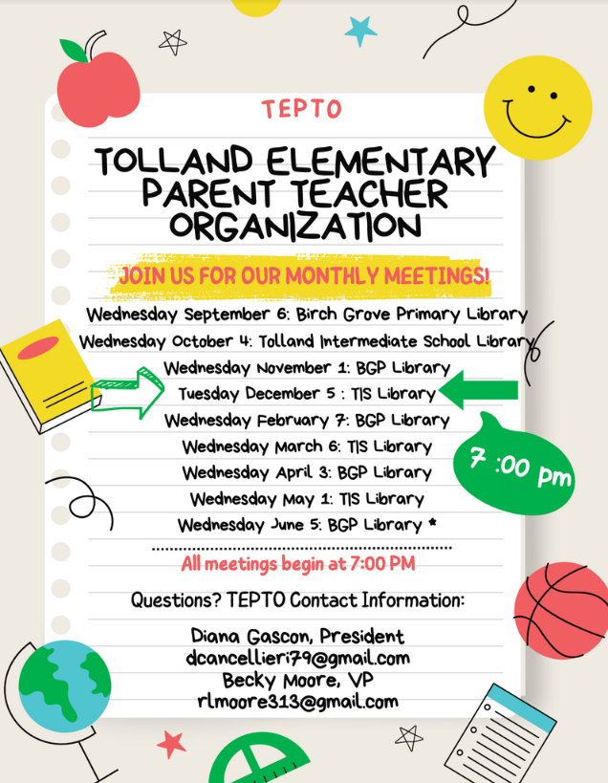
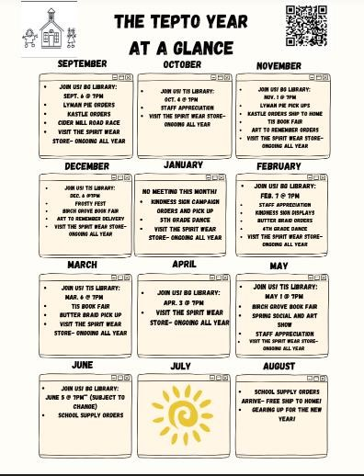

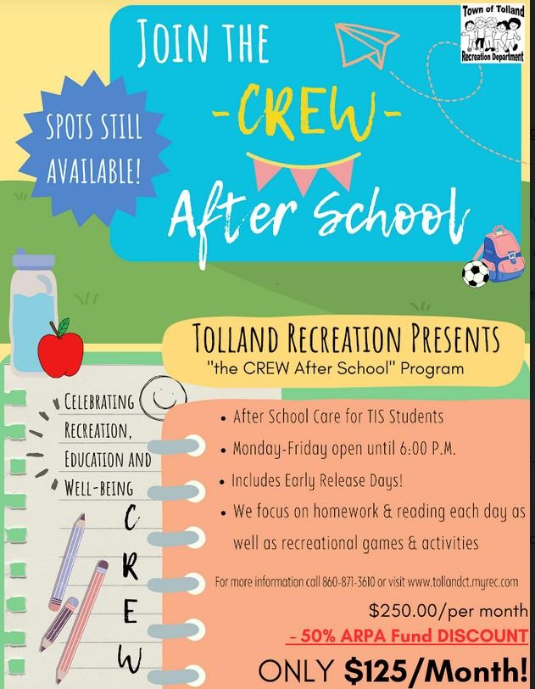
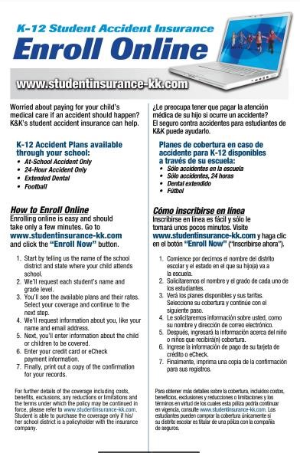
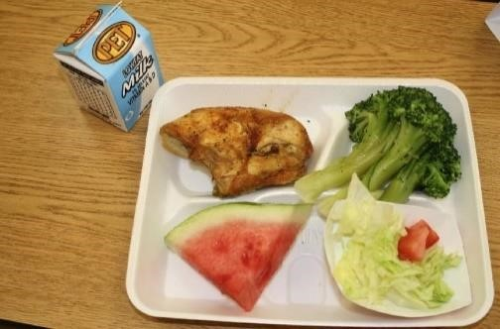
School Meals 2023-2024:
All students are eligible for a free breakfast each day. Students who qualify for free or reduced-price meals will also be eligible to receive one free lunch daily. ALL OTHER
LUNCHES WILL BE CHARGED AT THE CURRENT LUNCH PRICE PER SCHOOL.

Payment for these lunches is the responsibility of the parent or guardian.
The district participates in the National School Lunch Program and Breakfast Program which offers students nutritionally balanced meals daily. The lunch period is 30 minutes. Proper manners are always expected in the cafeteria. Free and reducedprice meals are available based on financial need. Information on this program may be obtained from the main office or Abby Kassman-Harned, the Food Service Director, at aharned@tolland.k12.ct.us or 870-6854.

We use a Point-of-Sale System that allows you to put money into an account for your child to purchase meals.

Scanning – All students will be scanned unless the parent or guardian opts out of this biometric identification procedure. When your child comes through the service line, he/she will scan his/her finger as a means of identification.

Payments – The cost of lunch at Birch Grove and Tolland Intermediate school is $3.15. One school breakfast is free for all students. One milk is provided for each lunch and breakfast. Ala carte milk is $0.75. You may sign up for “My School Account” and make your payments online. Your child may give payment along with a form to his/her classroom teacher to send to the office, or he/she may bring payment directly to the cashier in the cafeteria at mealtime. Your payment may take us a few days to process. It is important to keep a positive balance in your students’ accounts. If you have any questions or concerns, you may contact us at 860-870-6854 or aharned@tolland.k12.ct.us

The End

